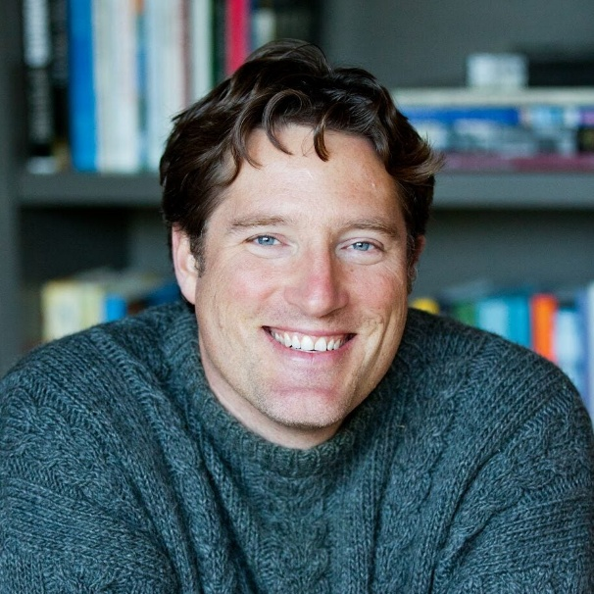 | 
Zachary Elkins  (University of Texas, Austin) | Tom Ginsburg  (University of Chicago)

